**Measuring Field of View (FOV)**

* The field of view is the circular area under observation when using a microscope.
* You need to know the diameter of the field of view to calculate the size of the specimen you are looking at.
* All you need to calculate the field diameter is a slide with a millimetre grid or ruler mounted on it.

The microscope you will be using has three different magnifications: 40×, 100×, and 400×. These are calculated by multiplying the magnification of the eyepiece lens (10×) by that of the objective lens (4×, 10× and 40×).

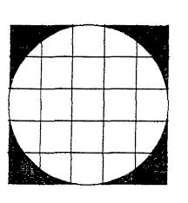**PART 1 – Calculating Field of View**

**Method:**

1. Place a slide with a minigrid on the stage.
2. Focus the microscope on low power (i.e. using the smallest lens). Make sure one of the lines of the minigrid lines up with the outer edge of the view.
3. Count the number of boxes that fit across the view. Each one of these boxes represents 1 mm.
4. Fill in the following information for **low power**.

|  |  |
| --- | --- |
| **Magnification** | **Number of boxes** |
|  |  |

1. Repeat the steps for the **medium power** objective lens.

|  |  |
| --- | --- |
| **Magnification** | **Number of boxes** |
|  |  |

1. Repeat again for **high power** (be careful not to use the coarse adjustment knob).

|  |  |
| --- | --- |
| **Magnification** | **Number of boxes** |
|  |  |

1. Fill in the table below with all the information you have gathered.

|  |  |  |
| --- | --- | --- |
| **Magnification** | **Number of boxes** | **Field of view (mm)** |
| 40× |  |  |
| 100× |  |  |
| 400× |  |  |

**PART 2 – Using FOV to estimate cell size**

**Method**

1. Place the minigrid slide on the stage.
2. Focus your microscope on the ‘e’ on low power.
3. Estimate how many ‘e’s would fit across the field of view (FOV).
4. Fill out the table below with the results.

|  |  |
| --- | --- |
| **FOV** | **Number of ‘e’s that fit** |
|  |  |

1. To work out the approximate size of the letter ‘e’ we must divide the FOV by the number of ‘e’s that fit across it. Do this in the table below.  
   For example, if you had a field of view of 10 mm and 2.5 cells fit across it you would divide 10 by 2.5 to get 4. The estimated size of the cell would be 4 mm.

|  |  |  |
| --- | --- | --- |
| **FOV** | **Number of ‘e’s that would fit** | **Size of ‘e’ (FOV ÷ number of ‘e’s)** |
|  |  |  |
|  |  |  |
|  |  |  |

1. Repeat for medium power and high power (do not use the coarse adjustment knob when using the high power lens). Do your results vary? Why or why not?
2. Pack away your microscope and return your slides.

**PART 3 – Practice Questions**

1. Calculate the Field of View of the following microscope views (each box is 1 mm).

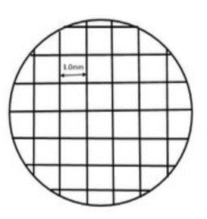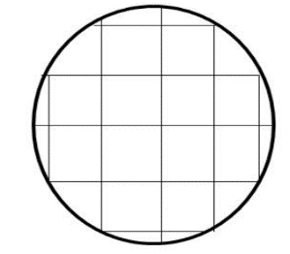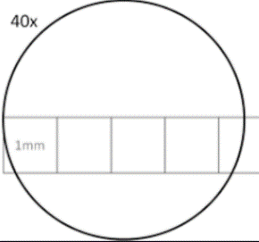

FOV = FOV = FOV =

1. Aaron was looking at three different slides through a microscope with a field of view of 2 mm. He noticed that on the first slide 2 cells fit across the FOV. Calculate the size of each cell.
2. Aaron’s second slide could fit 12 cells across. Calculate the size of each cell.
3. The final slide looked like this. Calculate the size of the cells.

